Assignment No.1

Title:

Setup a wired LAN using Layer 2 Switch. It includes preparation of cable, testing of cable using line tester, configuration machine using IP addresses, testing using PING utility and demonstrating the PING packets captured traces using Wireshark Packet Analyzer Tool.

Theory:

Cable Preparation

The cable will be constructed using either TIA/EIA T568A or T568B standards for Ethernet, which determines the color wire to be used on each pin.
Straight-through patch cables are normally used to connect a host directly to a hub or switch or to a wall plate in an office area. With a straight-through cable, the color of wire used by pin 1 on one end is the same color used by pin 1 on the other cable end, and similarly for the remaining seven pins.

With a crossover cable the second and third pairs on the RJ-45 connector at one end of the cable are reversed at the other end. The pin-outs for the cable are the T568A standard on one end and the T568B standard on the other end. Crossover cables are normally used to connect hubs and switches or can be used to directly connect two hosts to create a simple network.

TIA/EIA 568A and 568B Wiring Standards
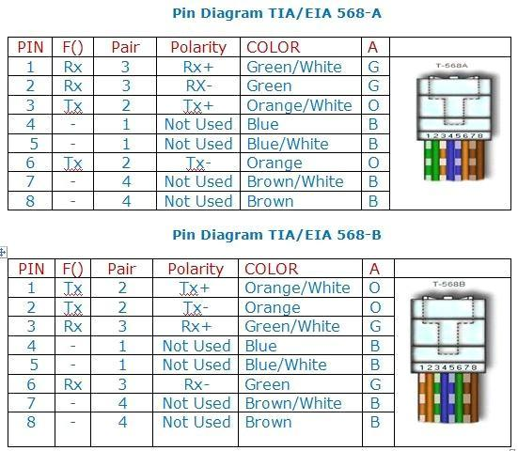

Prepare and test an Ethernet straight-through and Crossover patch cable

Step 1: Obtain and prepare the cable

- Determine the length of cable required. This could be the distance from a computer to a switch or between a device and an RJ-45 outlet jack.
- Using wire strippers, remove 5.08 cm (2 in.) of the cable jacket from both ends of the cable.

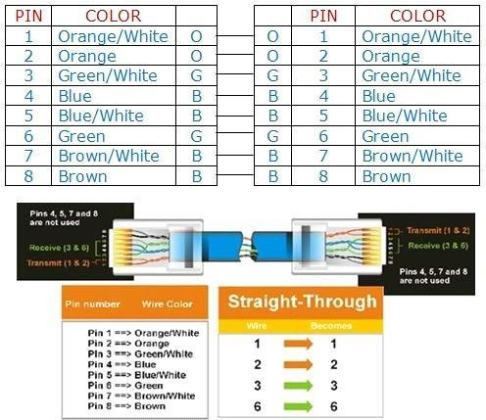
Pin Diagram TIA/EIA 568-B for Straight-Through Cabling

Pin Diagram EIA/TIA 568B for Cross-Over Cabling

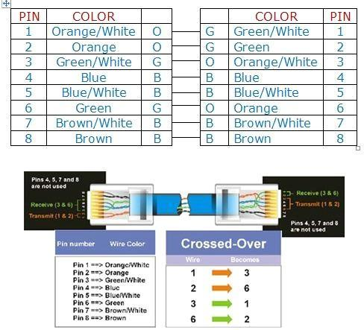

Step 2: Prepare and insert the wires
- Determine which wiring standard will be used. Circle the standard. [T568A | T568B] and locate the correct table or figure from the “Wire Diagrams” based on the wiring standard used.
- Spread the cable pairs and arrange them roughly in the desired order based on the standard chosen.
- Untwist a short length of the pairs and arrange them in the exact order needed by the standard moving left to right starting with pin 1.
- It is very important to untwist as little as possible. The twists are important because they provide noise cancellation
- Straighten and flatten the wires between your thumb and forefinger. Ensure the cable wires are still in the correct order as the standard.
- Cut the cable in a straight line to within 1.25 to 1.9 cm (1/2 to 3/4 in.) from the edge of the cable jacket. If it is longer than this, the cable will be susceptible to crosstalk (the interference of bits from one wire with an adjacent wire).
- The key (the prong that sticks out from the RJ-45 connector) should be on the underside pointing downward when inserting the wires. Ensure the wires are in order from left to right starting with pin 1. Insert the wires firmly into the RJ-45 connector until all wires are pushed as far as possible into the connector

Step 3: Inspect, crimp, and re-inspect

- Visually inspect the cable and ensure the right color codes are connected to the correct pin numbers.
- Visually inspect the end of the connector. The eight wires should be pressed firmly against the end of
the RJ-45 connector. Some of the cable jacket should be inside the first portion of the connector. This provides strain relief for the cable.
If the cable jacket is not far enough inside the connector, it may eventually cause the cable to fail.
- If everything is correctly aligned and inserted properly, place the RJ-45 connector and cable into the crimper. The crimper will push two plungers down on the RJ-45 connector.
- Visually re-inspect the connector. If improperly installed, cut the end off and repeat the process.

Step 4: Terminate the other cable end
- Use the previously described steps to attach an RJ-45 connector to the other end of the cable.
- Visually re-inspect the connector. If improperly installed, cut the end off and repeat the process.

Step 5: Test the cable

- Use the cable to connect a PC to a network.
- Visually check the LED status lights on the NIC card. If they are on (usually green or amber) the cable is functional.
- On the PC, open the command prompt.
- Type ifconfig
- Write down the default gateway IP address.
- Or you can use line tester to test the prepared cable.

Network Devices

Repeater:

Functioning at Physical Layer. A repeater is an electronic device that receives a signal and retransmits it at a higher level and/or higher power, or onto the other side of an obstruction, so that the signal can cover longer distances. Repeater have two ports ,so cannot be use to connect for more than two devices.

Hub:
An Ethernet hub, active hub, network hub, repeater hub, hub or concentrator is a device for connecting multiple twisted pair or fiber optic Ethernet devices together and making them act as a single network segment. Hubs work at the physical layer (layer 1) of the OSI model. The device is a form of multiport repeater. Repeater hubs also participate in collision detection, forwarding a jam signal to all ports if it detects a collision.

Switch:
A network switch or switching hub is a computer networking device that connects network segments. The term commonly refers to a network bridge that processes and routes data at the data link layer (layer 2) of the OSI model. Switches that additionally process data at the network layer (layer 3 and above) are often referred to as Layer 3 switches or multilayer switches.

Bridge:
A network bridge connects multiple network segments at the data link layer (Layer 2) of the OSI model. In Ethernet networks, the term bridge formally means a device that behaves according to the IEEE 802.1D standard. A bridge and switch are very much alike; a switch being a bridge with numerous ports. Switch or Layer 2 switch is often used interchangeably with bridge. Bridges can analyze incoming data packets to determine if the bridge is able to send the given packet to another segment of the network.

Router:
A router is an electronic device that interconnects two or more computer networks, and selectively interchanges packets of data between them. Each data packet contains address information that a router can use to determine if the source and destination are on the same network, or if the data packet must be transferred from one network to another. Where multiple routers are used in a large collection of interconnected networks, the routers exchange information about target system addresses, so that each router can build up a table showing the preferred paths between any two systems on the interconnected networks.

Gate Way:
In a communications network, a network node equipped for interfacing with another network that uses different protocols. A gateway may contain devices such as protocol translators, impedance matching devices, rate converters, fault isolators, or signal translators as necessary to provide system interoperability. It also requires the establishment of mutually acceptable administrative procedures between both networks. A protocol translation/mapping gateway
Interconnects networks with different network protocol technologies by performing the required protocol.

Building and Testing of Wired Network

- Crossover Cable

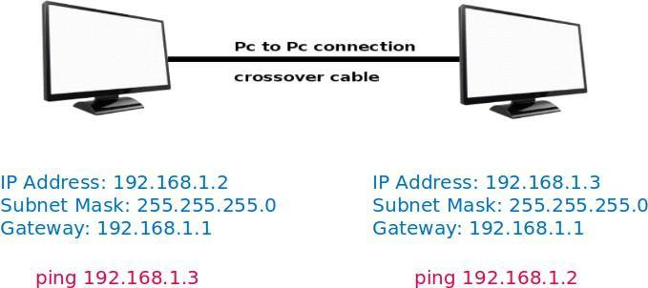
Connect two machines using crossover cable and configure it using ip address, subnet mask and gateway address as shown in figure. Ping from both the machines and capture ICMP packets in Wireshark tool.

Setting Up LAN using Straight-Through Cable
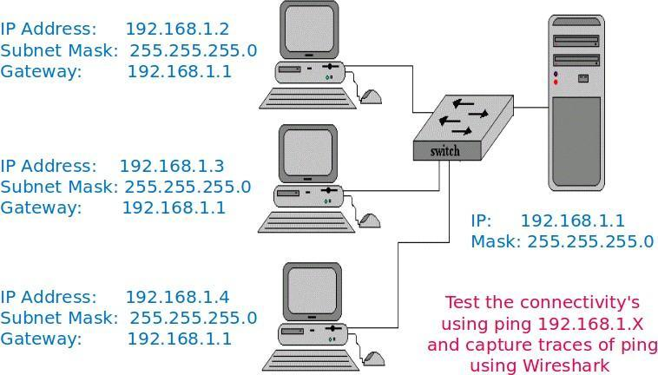

Figure 1
Connect four machines using Straight-Through cable to switch and router and then configure all using ip address, subnet mask and gateway address as shown in figure. Ping all the machines and capture ICMP packets in Wireshark tool.

Testing Web Server over LAN

  - Installation of Web Server – Apache2 or Tomcat7
  - Install the server – sudo apt-get install apache
  - Start web server - /etc/init.d/apache2 start
  - Create the web page and store in /var/www/http
  - Access the web pages from client machines 1/2/3
Test the web server by accessing web pages stored on server and capture the traces of http ,tcp, ip and Ethernet-II using Wireshark.

Conclusion:
Hence we have designed wired and wireless LAN using crossover and straight-through cable, and captured the ICMP, HTTP packets in Wireshark.

